Platforma .NET

Temat: Aplikacja do zarządzania hurtownią alkoholi "Alkobazar".

Członkowie grupy:

Kinga Sochacka 202293
Patryk Szmekel 202310
Kamil Baranowski 202111
Patryk Kochelski 202189

Do napisania aplikacji zostały użyte:

C# - backend
T-SQL – relacyjna baza danych SQL
ADO.NET – dostęp do bazy danych z poziomu Visual Studio 2017
Windows Forms – frontend

Diagram modelu oraz skrypt do odtworzenia bazy danych:

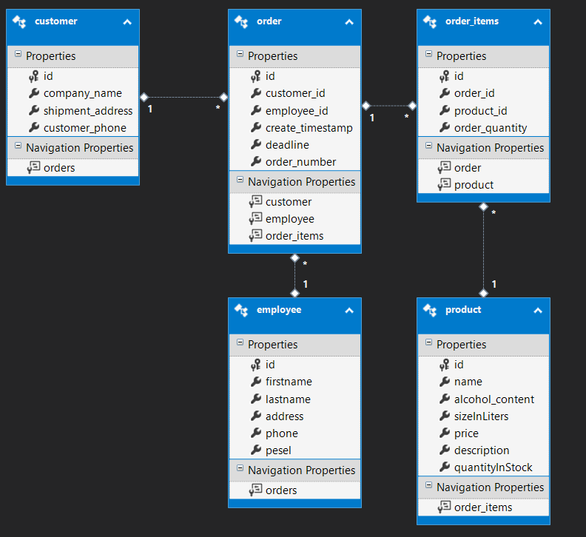

-- --------------------------------------------------
-- Creating all tables
-- --------------------------------------------------

-- Creating table 'customers'
CREATE TABLE [dbo].[customers] (
[id] int IDENTITY(1,1) NOT NULL,
[company_name] varchar(50) NOT NULL,
[shipment_address] varchar(100) NOT NULL,
[customer_phone] varchar(50) NOT NULL
);
GO

-- Creating table 'employees'
CREATE TABLE [dbo].[employees] (
[id] int IDENTITY(1,1) NOT NULL,
[firstname] varchar(50) NOT NULL,
[lastname] varchar(50) NOT NULL,
[address] varchar(100) NOT NULL,
[phone] varchar(20) NOT NULL,
[pesel] varchar(20) NOT NULL
);
GO

-- Creating table 'order_items'
CREATE TABLE [dbo].[order_items] (
[id] int IDENTITY(1,1) NOT NULL,
[order_id] int NOT NULL,
[product_id] int NOT NULL,
[order_quantity] int NOT NULL
);
GO

-- Creating table 'orders'
CREATE TABLE [dbo].[orders] (
[id] int IDENTITY(1,1) NOT NULL,
[customer_id] int NOT NULL,
[employee_id] int NOT NULL,
[create_timestamp] datetime NOT NULL,
[deadline] datetime NOT NULL,
[order_number] varchar(30) NOT NULL
);
GO

-- Creating table 'products'
CREATE TABLE [dbo].[products] (
[id] int IDENTITY(1,1) NOT NULL,
[name] varchar(50) NOT NULL,
[alcohol_content] float NOT NULL,
[sizeInLiters] float NOT NULL,
[price] float NOT NULL,
[description] varchar(100) NULL,
[quantityInStock] int NOT NULL
);
GO

-- --------------------------------------------------
-- Creating all PRIMARY KEY constraints
-- --------------------------------------------------

-- Creating primary key on [id] in table 'customers'
ALTER TABLE [dbo].[customers]
ADD CONSTRAINT [PK_customers]
PRIMARY KEY CLUSTERED ([id] ASC);
GO

-- Creating primary key on [id] in table 'employees'
ALTER TABLE [dbo].[employees]
ADD CONSTRAINT [PK_employees]
PRIMARY KEY CLUSTERED ([id] ASC);
GO

-- Creating primary key on [id] in table 'order_items'
ALTER TABLE [dbo].[order_items]
ADD CONSTRAINT [PK_order_items]
PRIMARY KEY CLUSTERED ([id] ASC);
GO

-- Creating primary key on [id] in table 'orders'
ALTER TABLE [dbo].[orders]
ADD CONSTRAINT [PK_orders]
PRIMARY KEY CLUSTERED ([id] ASC);
GO

-- Creating primary key on [id] in table 'products'
ALTER TABLE [dbo].[products]
ADD CONSTRAINT [PK_products]
PRIMARY KEY CLUSTERED ([id] ASC);
GO

-- --------------------------------------------------
-- Creating all FOREIGN KEY constraints
-- --------------------------------------------------

-- Creating foreign key on [customer_id] in table 'orders'
ALTER TABLE [dbo].[orders]
ADD CONSTRAINT [FK_customer_fkey]
FOREIGN KEY ([customer_id])
REFERENCES [dbo].[customers]
([id])
ON DELETE NO ACTION ON UPDATE NO ACTION;
GO

-- Creating non-clustered index for FOREIGN KEY 'FK_customer_fkey'
CREATE INDEX [IX_FK_customer_fkey]
ON [dbo].[orders]
([customer_id]);
GO

-- Creating foreign key on [employee_id] in table 'orders'
ALTER TABLE [dbo].[orders]
ADD CONSTRAINT [FK_empId_fkey]
FOREIGN KEY ([employee_id])
REFERENCES [dbo].[employees]
([id])
ON DELETE NO ACTION ON UPDATE NO ACTION;
GO

-- Creating non-clustered index for FOREIGN KEY 'FK_empId_fkey'
CREATE INDEX [IX_FK_empId_fkey]
ON [dbo].[orders]
([employee_id]);
GO

-- Creating foreign key on [order_id] in table 'order_items'
ALTER TABLE [dbo].[order_items]
ADD CONSTRAINT [FK_orders_fkey]
FOREIGN KEY ([order_id])
REFERENCES [dbo].[orders]
([id])
ON DELETE NO ACTION ON UPDATE NO ACTION;
GO

-- Creating non-clustered index for FOREIGN KEY 'FK_orders_fkey'
CREATE INDEX [IX_FK_orders_fkey]
ON [dbo].[order_items]
([order_id]);
GO

-- Creating foreign key on [product_id] in table 'order_items'
ALTER TABLE [dbo].[order_items]
ADD CONSTRAINT [FK_product_fkey]
FOREIGN KEY ([product_id])
REFERENCES [dbo].[products]
([id])
ON DELETE NO ACTION ON UPDATE NO ACTION;
GO

-- Creating non-clustered index for FOREIGN KEY 'FK_product_fkey'
CREATE INDEX [IX_FK_product_fkey]
ON [dbo].[order_items]
([product_id]);
GO

